MySQL with Node.js

## Calling the Stored Procedure

Step 1: Create the Stored Procedure on your MySQL server

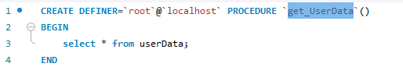

And test for the Stored procedure execution also



Step 2: Front end application and Call this procedure using Node.js

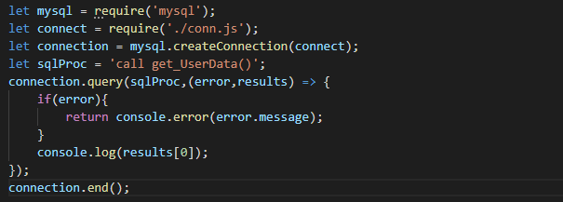

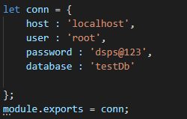

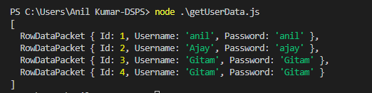

## Example with Filters

Step1: First let;s create the stored procedure on your server

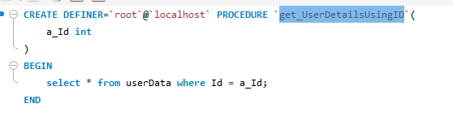

Step 2: Go to front end application and call this procedure, save it into an object

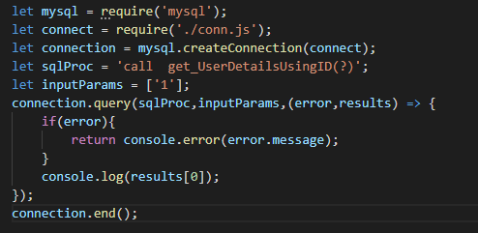

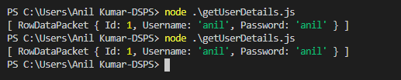

## Task : Write the Procedure for insertion and call the procedure from the Node.js application

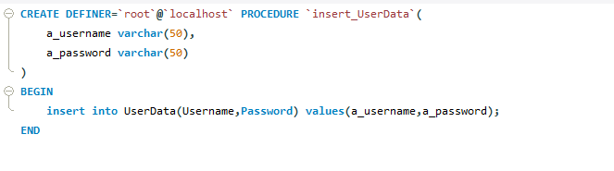

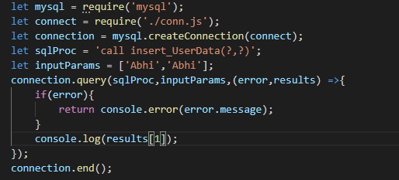

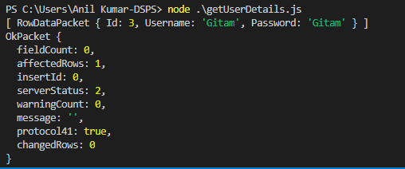

## Task : Write the Procedure for Delete and call the procedure from the Node.js application

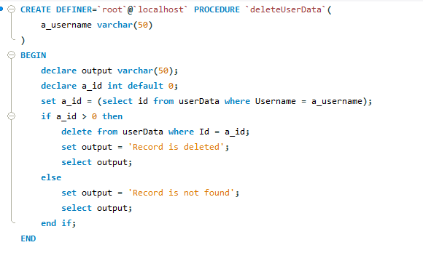

## Task : Write the Procedure for Update and call the procedure from the Node.js application

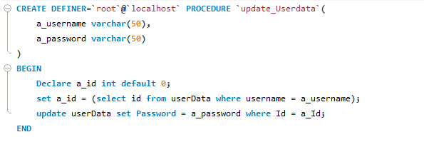

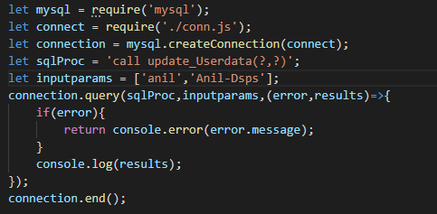

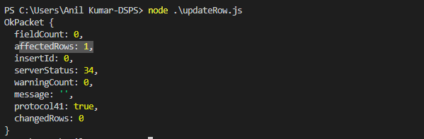

Change the Procedure on MySQL server and again execute the application

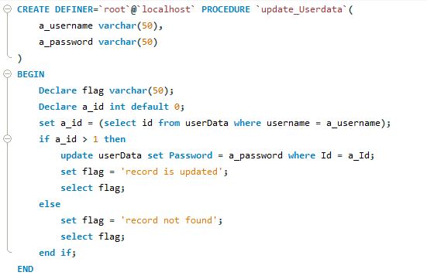

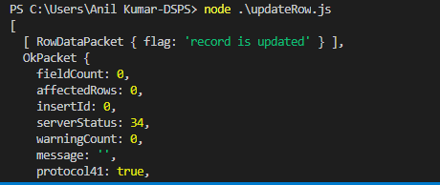

## Task: Create a Small Feedback form with two input fields

1. EmailId
2. Feedback

First of all you need to create the table on a database with few fields.

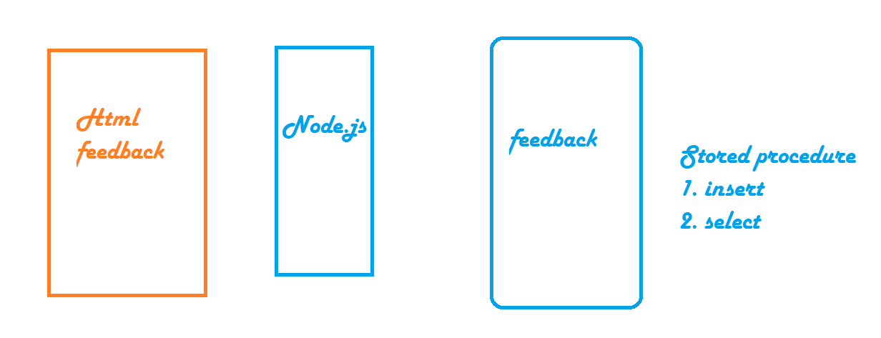

Two packages to be installed in your application

1. npm install express
2. npm install body-parser